SYSTEM ANALYSIS & DESIGN

Data Flow Diagrams (DFD) & System Class Diagram

Student Name | Academic ID
Mohamed Medhat Mohamed Ibrahim | 1202540904
Mohamed Ahmed Mohamed Abo-Shaheen | 1202540840
Mohamed Reda Mohamed Farag | 1202540862
Ibrahim Mohamed Mahmoud Khairy | 1202540507

Team Members
1. System Class Diagram
The class diagram presents the main classes of the Event Ticketing System, their attributes and operations, and the relationships used to support ticket purchasing and QR check-in.
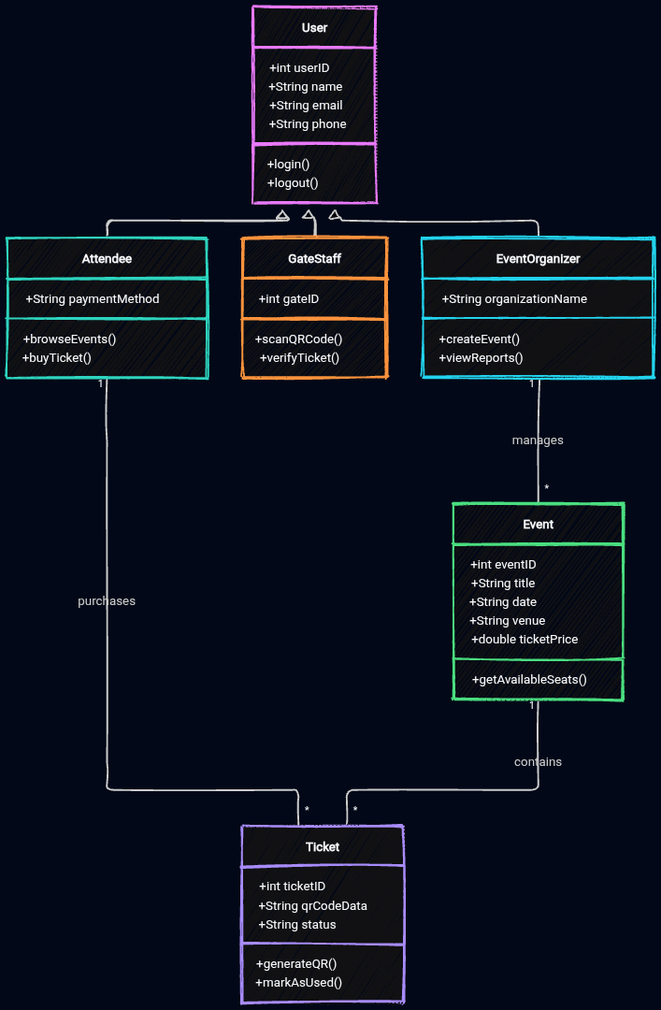

Class Structure Summary
- User (Base Class): Shared account information and login/logout operations.
- Attendee: Browses events, purchases tickets, and presents QR codes at entry.
- GateStaff: Scans QR codes and verifies tickets at event entrances.
- EventOrganizer: Creates and manages event details and views reports.
- Event: Stores event details such as title, date, venue, and ticket price.
- Ticket: Stores ticket ID, QR data, and ticket status.

2. Data Flow Diagram (DFD) – Context Level
The context diagram shows the system as one main process and the data exchanged with the external entities: Attendee, Gate Staff, and Event Organizer.
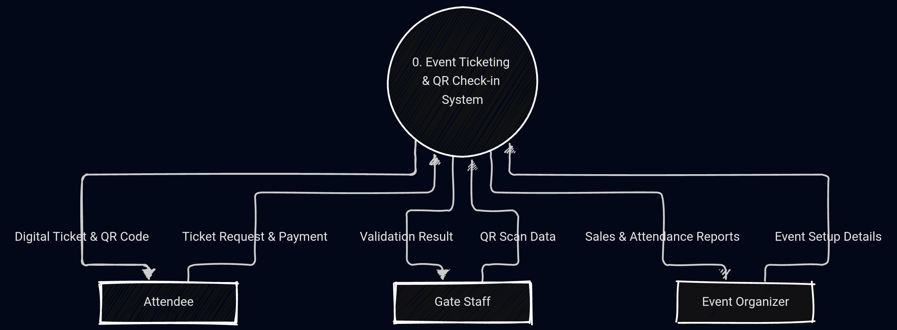

Data Flow Summary
- Attendee: Sends ticket requests and payment details; receives a digital ticket with a unique QR code.
- Gate Staff: Sends scanned QR data; receives a validation result such as valid, invalid, or already used.
- Event Organizer: Sends event setup details; receives sales and attendance reports.

3. Data Flow Diagram (DFD) – Level 1
The Level 1 DFD expands the system into its main processes and shows how they exchange data with external entities and the Events & Tickets Database.
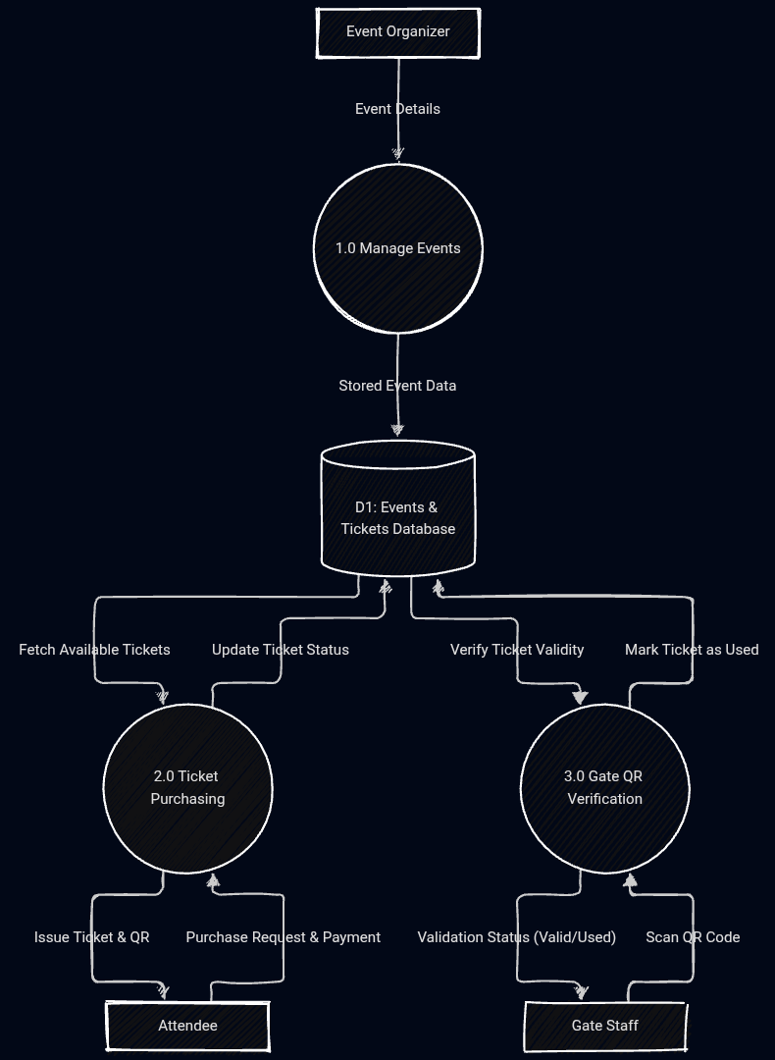

Level 1 Process Summary
- Process 1.0 – Manage Events: The Event Organizer submits event details, which are stored in the database.
- Process 2.0 – Ticket Purchasing: The Attendee submits a purchase request and payment details; the system checks availability and issues a ticket and QR code.
- Process 3.0 – Gate QR Verification: Gate Staff submits scanned QR data; the system checks ticket validity, returns a validation status, and marks a successfully used ticket.

